4

Automation of the FDA Database Research

Process Definition Document

Version 1.3

|  |  |
| --- | --- |
| **Project Name** | Automation of the FDA Database Research Process |
| **Date** | 05th November 2020 |
| **Version** | 1.3 |
| **Business Unit** | Tech Underwriting |
| **Purpose** | Gather relevant information |

# Acceptance Management

|  |  |
| --- | --- |
| **Document Information** | |
| **Authored By** | Pallavi Thakare |
| **Contributors** | RNT Team |
| **Reviewers** | Meng Li  Prashant Hinge  Mina Hernandez  Felicia R Burton  Kori R Johnston  Krista L Hartin  John P Nanny |
| **Approvers** | Prashant Hinge  Mina Hernandez |
| **Project Sponsor** | Mina Hernandez |

Contents

Acceptance Management 2

Contents 3

List of Tables 5

List of Figures 5

1. Introduction 6

1.1. Purpose of the document 6

1.2. Objectives 6

1.3. Process key contacts 7

1.4. Minimum Pre-requisites for automation 7

2. Current Process Description (AS-IS) 8

2.1. Process Overview 11

2.2. Additional sources of process documentation 11

2.3. Target Systems 11

2.4. Impacted Business Area 12

3. TO-BE Process Description 12

3.1. Automation Solution Process Flow 13

3.2. Requirement Details 14

3.2.1. Step # 1: Enter “Establishment Name” in the Search box. 14

3.2.2. Step # 2: List of establishment names 15

3.2.3. Step # 3: UW will choose required establishment name from the list. 16

3.2.4. Step # 4: To get latest details click “Refresh” button 16

3.2.5. Step # 5: Enter the URL 17

3.2.6. Step # 6: Bot will enter “Establishment or Trade Name” in the respective field. 18

3.2.7. Step # 7: Bot will click on “Show all # listings” 18

3.2.8. Step # 8: Click on Establishment Name to capture Address 19

3.2.9. Step # 9: Navigate back to Step #7 20

3.2.10. Step # 10: Click on product from product list 20

3.2.11. Step # 11: Click on Premarket Submission Number 21

3.2.12. Step # 12: If Premarket Submission Number is not available, click on Product Code 22

3.2.13. Step # 13: Click on TPLC Product Code Report 22

3.2.14. Step # 14: Check Premarket Submission link availability. 23

3.2.15. Step # 15: Click on TPLC Product Code Report to capture top five device problems. 24

3.2.16. Step # 16: Enter the URL to capture 510(k) table 24

3.2.17. Step # 17: Bot will enter Establishment Name in the “Applicant Name” field. 25

3.2.18. Step # 18: Enter the URL to capture the Recalls details. 26

3.2.19. Step # 19: Bot will Enter Establishment name in the “Recalling Firm” field 26

3.2.20. Step # 20: Click on each link one by one under Product Description 27

3.2.21. Step # 21: Enter the URL to capture the MAUDE details 28

3.2.22. Step # 22: Bot will enter Establishment name in the “Manufacturer” field 28

3.2.23. Step # 23: Click on each Brand name 29

3.2.24. Step # 24: Enter the URL to capture the Warning Letters details 30

3.2.25. Step # 25: Enter Establishment name in search field. 31

3.2.26. Step # 26: Bot will enter the URL to capture Inspections details. 31

3.2.27. Step # 27: Bot will enter Establishment name in Firm Name field. 32

3.2.28. Step # 28: Retrieving details from database 33

3.3. Business Exceptions Handling 34

3.3.1 Known Exceptions 34

3.3.2 Unknown Exceptions 35

3.4. Application Error and Exceptions Handling 36

3.4.1 Known errors or Exceptions 36

3.4.2 Unknown Errors and Exceptions 36

3.5. Assumptions 36

3.6. Dependencies 36

3.7. Constraints 37

3.8. Risks 37

4. Acronyms and Glossary 37

5. Change History 37

**List of Tables**

Table 1: Process Key Contact Information 7

Table 2: General Information about current process 11

Table 3: Target Systems for RPA Bot 11

Table 4: Known Business Exceptions for Bot 35

Table 5: Known Application Exceptions for Bot 36

Table 6: Assumptions for the Bot 36

Table 7: Dependencies for the Bot 36

Table 8: Constraints for the Bot 37

Table 9: Risks for the Bot 37

Table 10: Acronyms and Glossary 37

Table 11: Change History 37

**List of Figures**

Figure 1: AS- IS Process Flow 10

Figure 2: Automated Solution Process Flow for Bot 13

Figure 3: Screen to input Establishment Name 14

Figure 4: Search Results 15

Figure 5: Selected Establishment name 16

Figure 6: Refresh Button 17

Figure 7: FDA Weblink Page 17

Figure 8: List of all entities 18

Figure 9: List of all devices under one entity 19

Figure 10: Address of Establishment 19

Figure 11: Details of product. 20

Figure 12: 510(k) Premarket Notification page 21

Figure 13: Product Classification Page 22

Figure 14: Top Five Device Problems 23

Figure 15: Product Classification Page 23

Figure 16: Top five device problems 24

Figure 17: 510(k) Premarket Notification page 24

Figure 18: 510(K) Premarket Notification Table 25

Figure 19: Medical Device Recalls Page 26

Figure 20: Medical Device Recalls Table 27

Figure 21: Recall Details Page 27

Figure 22: MAUDE page 28

Figure 23: MAUDE Table 29

Figure 24: Maude Adverse Event Report 30

Figure 25: Warning Letter Page 30

Figure 26: Warning Letter Table 31

Figure 27: Inspection Classification Database Search Page 32

Figure 28: Inspection Classification Database Search Table 33

Figure 29: Output screen 33

# Introduction

## Purpose of the document

The purpose of this document is to detail the Robotic Process Automation (RPA) process flow, system interactions and the TO-BE automation process carried out by the RPA Bot.

Tech Underwriting- FDA Research is a comprehensive FDA database research to help Life Science Underwriter qualify individual risk. The underwriter must click on the FDA weblink to access the database. The underwriter will have a list of all the establishments that needs to be searched for. If the products are available under the searched establishment, the underwriter will collect all the required data for each product of that establishment in an excel and save it with the establishment name which will be the output report. The process must be repeated until the data for all establishments is collected. It takes 30-45 mins for an underwriter to collect all the required data for each medical device which slows down the Life Science UW process.

The goal here is to eliminate repetitive and time-consuming data research tasks, optimize Life Science underwriter’s risk control process thus improve agent’s satisfaction and relationship.

## Objectives

The business objectives and benefits expected by the Business Process Owner after automation of the selected business process are:

* Eliminate repetitive and time-consuming data research tasks
* Optimize Life Science underwriter’s risk control process thus Improve Agent’s satisfaction and relationship
* **Operational Efficiencies-** Enable Life Science team to immediately respond to agent’s inquiry and other business inquiry
* **Insights and Analytics-** Digital output data in consistent format could feed into Insights and Analytics platform to generate matrix for further analysis
* **Talent-** Attract and retain strong talent by removing the heavy lifting work workflow and enable them to focus on tasks promote their professional developments
* **Cost Savings-** 
  + 30 - 45 (mins) saved for UW on FDA research per device- ~600 hours per year
  + 840+ accounts with 10 devices per account are researched by UW each year with YOY over 20% NB growth rate
  + ROI- 4x

## Process key contacts

|  |  |  |  |
| --- | --- | --- | --- |
| *Role* | *Name* | *Contact details*  *(email, phone number)* | *Notes* |
| **Process SME** | Mina Hernandez  Felicia R Burton  Kori R Johnston  Krista L Hartin  John P Nanny | [MHERNANDEZ@HANOVER.COM](mailto:MHERNANDEZ@HANOVER.COM)  [FBURTON@HANOVER.COM](mailto:FBURTON@HANOVER.COM)  [KJOHNSTON@hanover.com](mailto:KJOHNSTON@hanover.com)  [KHARTIN@HANOVER.COM](mailto:KHARTIN@HANOVER.COM)  [JNANNEY@HANOVER.COM](mailto:JNANNEY@HANOVER.COM) | Point of contact for questions related to business rules and business expectations |
| **Project Manager** | Prashant Hinge | PHINGE@HANOVER.COM | Project Manager, and Point of Contact related to Coordination, Project timelines, and contact with any other team members |
| **Process Reviewer** | Meng Li | MLI@HANOVER.COM | Point of Contact for process exceptions |
| **Process Owner/ Approver for production** | Prashant Hinge | PHINGE@HANOVER.COM | Escalations, Delays |

Table 1: Process Key Contact Information

## Minimum Pre-requisites for automation

* Filled in Process Definition Document
* Credentials (user ID and password) required to logon to machines and applications
* Test Data to support development.
* Smoke test applications
* Win Automation Installation
* PowerApps License
* MS-Excel should be available

# Current Process Description (AS-IS)

Currently, the UWs click on the weblink for FDA Database. Then, they manually enter the information needed from the link. The UW must click approximately 20 times to get information about 1 device for one establishment. Parallelly the UW must enter each piece of information into excel workbook. Depicted below is the AS-IS flow –

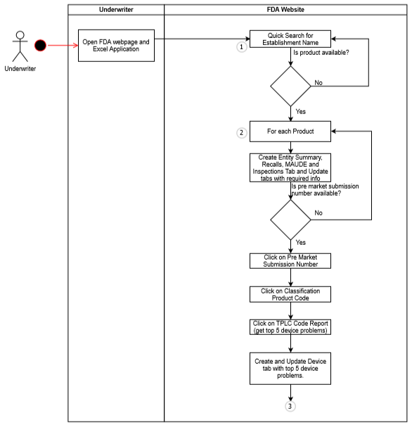

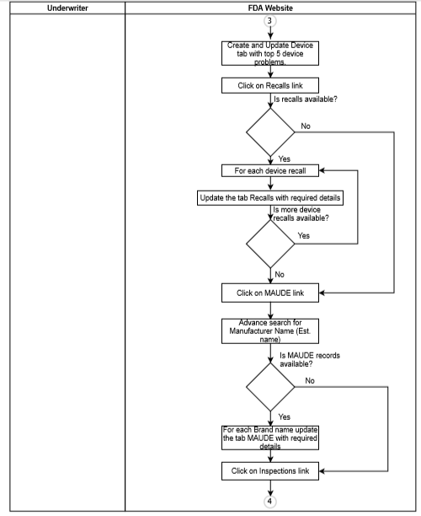

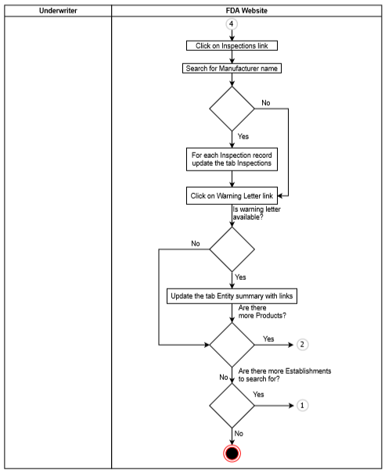

Figure 1: AS- IS Process Flow

## Process Overview

General information about the process selected for RPA prior to automation.

|  |  |  |
| --- | --- | --- |
| # | Item | Description |
| 1 | **Process full name** | FDA Database Research Process |
| 2 | **Process Area** | Tech Underwriting |
| 3 | **Department** | Tech Underwriting |
| 4 | **Process short description**  (operation, activity, outcome) | UW accesses the weblink for FDA, searches for specific establishment name, extract all the required information into specific format and saves it in excel for further analysis. |
| 5 | **Role(s) required for performing the process** | Underwriters |
| 6 | **Process schedule and frequency** | Ad hoc – whenever the UW wishes to run this process |
| 7 | **# of items processes /month** | Assuming 700/month |
| 8 | **Average handling time per item** | 30-45 minutes |
| 9 | **Peak period (s)** | -unknown- |
| 10 | **Total # of FTEs supporting this activity** | -To be confirmed from business- |
| 11 | **Level of exception rate** | -unknown- |
| 12 | **Input data** | Establishment Name |
| 13 | **Output data** | Excel file with extracted data |
| 14 | **Dependencies**  (upstream, downstream) | Access to FDA website |

Table 2: General Information about current process

## Additional sources of process documentation

* FDA Crawler Instructions & Output file
* FDA Project Charter

## Target Systems

|  |  |  |  |  |  |  |
| --- | --- | --- | --- | --- | --- | --- |
| **#** | **Application Name & Version** | **System**  **Language** | **Login Module** | **Interface** | **Environment/**  **Access method** | **Comments**  **(Include URLs)** |
| 1 | MS-Excel | EN | n/a | Client | Local desktop | - |
| 2 | Web Browse- Internet Explorer (11) | EN | n/a | Client | Local desktop | - |
| 3 | PowerApps | EN | - | Client | Local desktop | - |

Table 3: Target Systems for RPA Bot

## Impacted Business Area

The main impact of this project is on the Underwriters, that need to search the FDA database, to extract the required data in excel.

# TO-BE Process Description

The automation solution for the existing time-consuming manual database research process would be, the underwriter will provide the establishment name in Search area of PowerApps.

**Case 1: If the provided establishment name exists in the database-**

The search result will display a list of related establishment names with already existing data. The UW can view or download the details available. If the UW wants to view/download latest details, they have to click on “Refresh” button. This will trigger the Bot to capture latest details for provided establishment name from the FDA weblink, which will be saved in the database and will be reflected on the PowerApps screen.

**Case 2: If the provided establishment name does not exist in the database-**

In case the provided establishment name does not exist in the database, the Bot will get triggered to capture the details for provided establishment name from FDA weblink. These details will be saved in database and can be viewed or downloaded using PowerApps.

When triggered, in the backend, the Bot will capture the details required for the Entity Summary, Recalls, MAUDE, Inspections and Warning letters from the FDA website. It will fill in the information captured from the website to the database into the corresponding tables and columns. If there are no values available, the automation will add a message “No Results Found”. For the errors encountered, the automation will log the error in error table along with screenshots and save them.

The extracted details in database can be accessed anytime through PowerApps with hyperlinks and formatting wherever required.

## Automation Solution Process Flow

Figure 2: Automated Solution Process Flow for Bot

## Requirement Details



### Step # 1: Enter “Establishment Name” in the Search box.

**Process**

|  |  |  |  |
| --- | --- | --- | --- |
| Input | Process | Output | Exceptions |
| Underwriter will enter Establishment name in the Search box of PowerApps screen. | - | Figure 3: Screen to input Establishment Name | If no records are found the bot will be triggered to extract details for provided establishment name |

**Output**

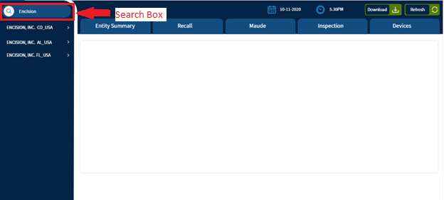

Figure 3: Screen to input Establishment Name

### Step # 2: List of establishment names

**Process**

|  |  |  |  |
| --- | --- | --- | --- |
| Input | Process | Output | Exceptions |
| - | In response, the search result will display the list of establishment names for UW to choose. | Figure 4: Search Results | - |

**Output**

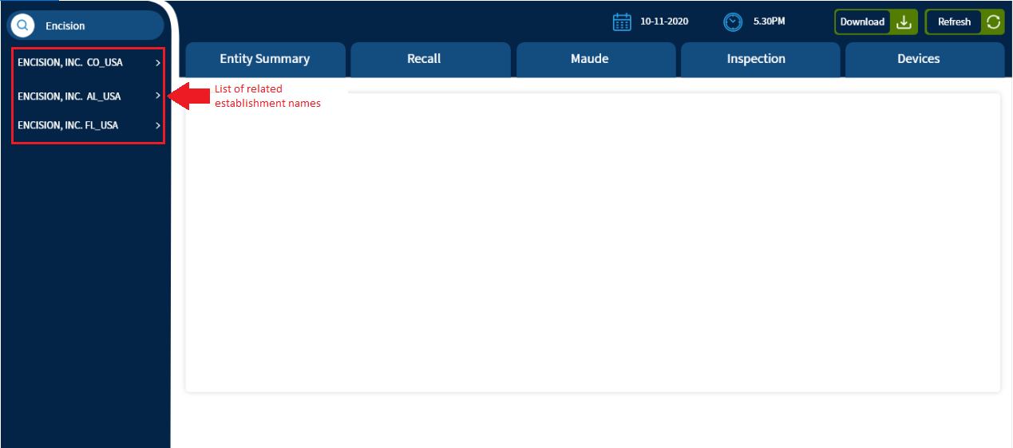

Figure 4: Search Results

### Step # 3: UW will choose required establishment name from the list.

**Process**

|  |  |  |  |
| --- | --- | --- | --- |
| Input | Process | Output | Exceptions |
| Establishment name | - | Figure 5: Selected Establishment name | If the UW needs the latest details for the establishment name, they will click on “Refresh” button. |

**Output**

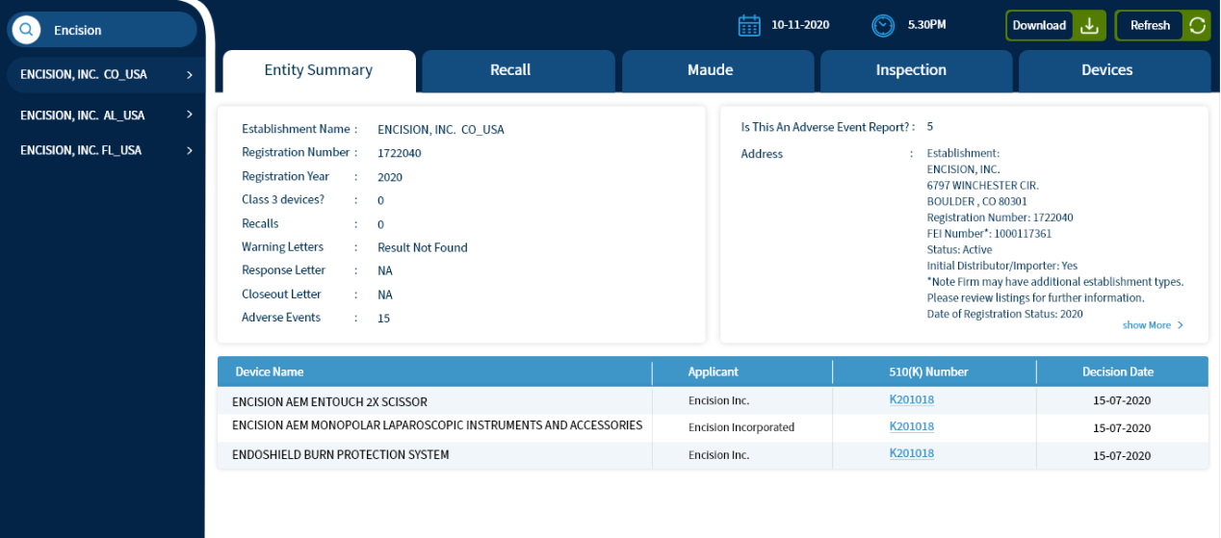

Figure 5: Selected Establishment name

### Step # 4: To get latest details click “Refresh” button

If the UW needs the latest details for the establishment name, they will click on “Refresh” button. This will trigger the Bot to extract the latest data from the FDA link for the provided establishment name.

**Process**

|  |  |  |  |
| --- | --- | --- | --- |
| Input | Process | Output | Exceptions |
| Click on “Refresh” button | Trigger the RPA Bot | Figure 6: Refresh Button | NA |

**Output**

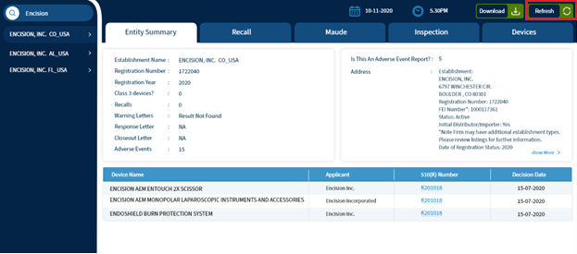

Figure 6: Refresh Button

### Step # 5: Enter the URL

**Process**

|  |  |  |  |
| --- | --- | --- | --- |
| Input | Process | Output | Exceptions |
| The bot will enter the URL | Open the URL:  <https://www.accessdata.fda.gov/scripts/cdrh/cfdocs/cfRL/rl.cfm> | Figure 7: FDA Weblink Page | NA |

**Output**  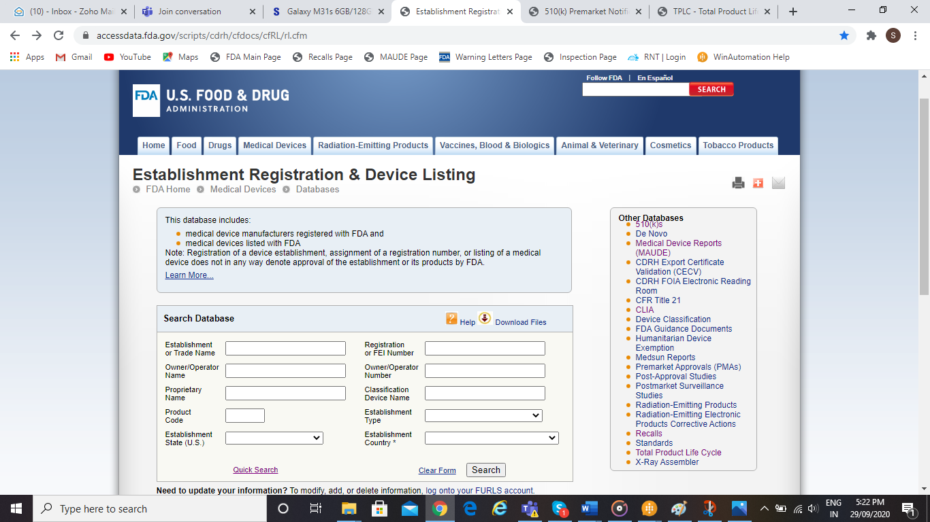

Figure 7: FDA Weblink Page

### Step # 6: Bot will enter “Establishment or Trade Name” in the respective field.

**Process**

|  |  |  |  |  |  |  |
| --- | --- | --- | --- | --- | --- | --- |
| Input | | Process | | Output | | Exceptions |
| Establishment name. | Bot will enter the Establishment Name provided by user into the field “Establishment or Trade Name” and will click on Search button. | | Figure 8: List of all entities | | - | | |

**Output**

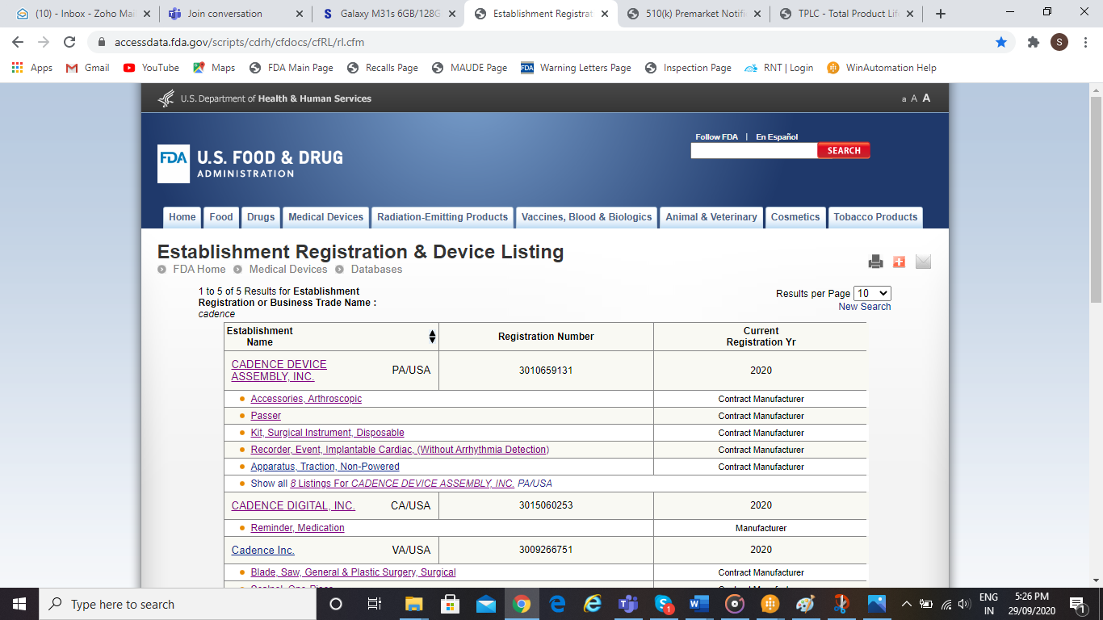

Figure 8: List of all entities

### Step # 7: Bot will click on “Show all # listings”

**Process**

|  |  |  |  |
| --- | --- | --- | --- |
| Input | Process | Output | Exceptions |
| Click on “Show all # listings”. | Bot will click on “Show all # listings” to read all the devices data falling under that particular entity. | Figure 9: List of all devices under one entity | NA |

**Output**

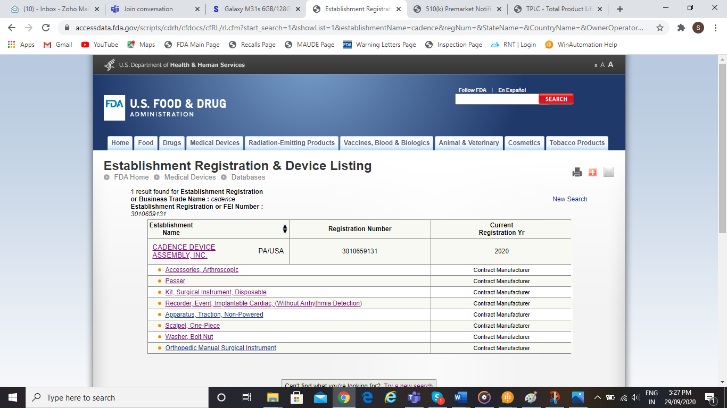

Figure 9: List of all devices under one entity

### Step # 8: Click on Establishment Name to capture Address

**Process**

|  |  |  |  |
| --- | --- | --- | --- |
| Input | Process | Output | Exceptions |
| Click on Establishment Name. | Bot will click on Establishment name capture and save the address in address column of “Entity Summary” table | Figure 10: Address of Establishment | NA |

**Output**

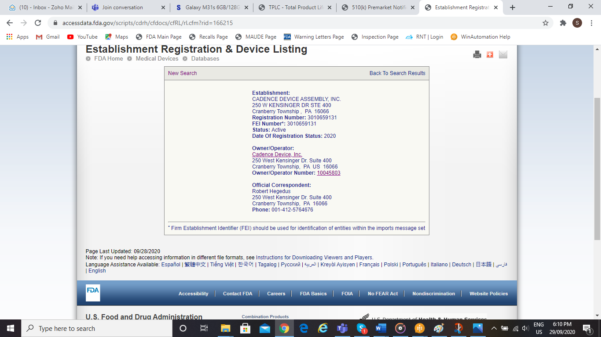

Figure 10: Address of Establishment

### Step # 9: Navigate back to Step #7

Navigate back to Step #7 output page Figure 8: List of all devices under one entity.

### Step # 10: Click on product from product list

**Process**

|  |  |  |  |
| --- | --- | --- | --- |
| Input | Process | Output | Exceptions |
| Click on Product from Product list | Bot will click on each product from the list, capture the required details and populate it into respective columns in the database | Figure 11: Details of product. | For any field, if there is no data available, the bot will log a message in error table along with screenshot and will enter” Results Not Found”. |

**Output**  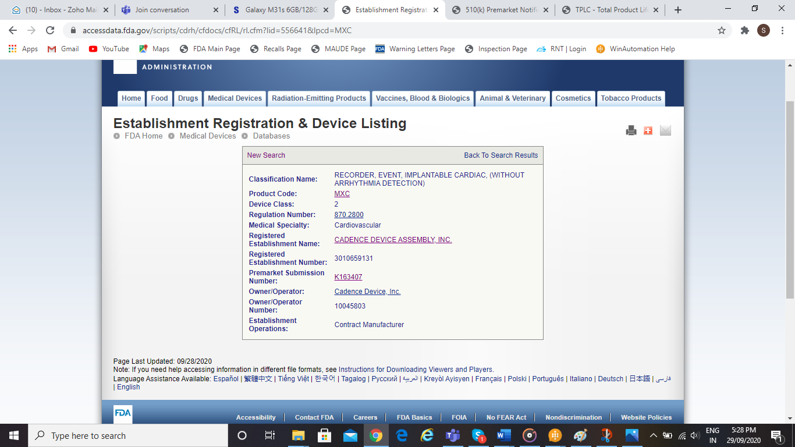

Figure 11: Details of product.

### Step # 11: Click on Premarket Submission Number

**Process**

|  |  |  |  |
| --- | --- | --- | --- |
| Input | Process | Output | Exceptions |
| Click on Premarket Submission Number | Bot will click on Premarket submission Number and to capture further details like Device name, Product Code,  Device Class, Regulation Number, Premarket Submission Number, Establishment Operations, CDRH Recalls, Summary Link and populate it into respective columns of database. | Figure 12: 510(k) Premarket Notification page | * If Premarket Submission Number is not available, the bot will log a message in error table “Premarket Submission Number” not found * If Summary/Statement link is not found, Device name will not be hyperlinked in Device table * If CDRH link is not found, recalls label will not be hyperlinked in Device table and bot will log message “No recalls found” in Entity Summary table. |

**Output**

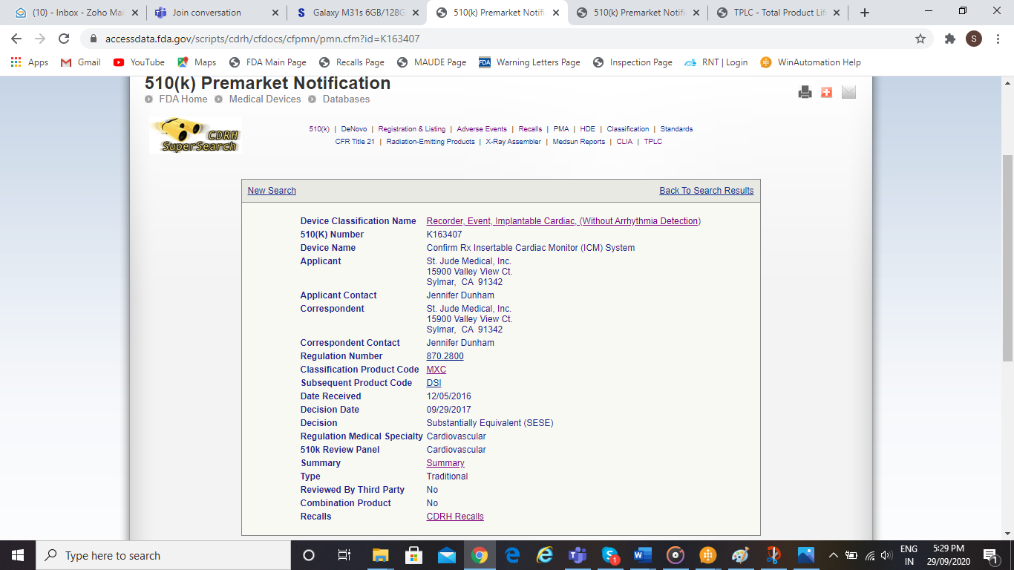

Figure 12: 510(k) Premarket Notification page

### Step # 12: If Premarket Submission Number is not available, click on Product Code

**Process**

|  |  |  |  |
| --- | --- | --- | --- |
| Input | Process | Output | Exceptions |
| Click on Product Code | Bot will check if Premarket Submission Number is available or not.If Premarket Submission Number is not available it will click on Product Code | Figure 13: Product Classification Page | In error table log a message “Premarket Submission Number not found” |

**Output**

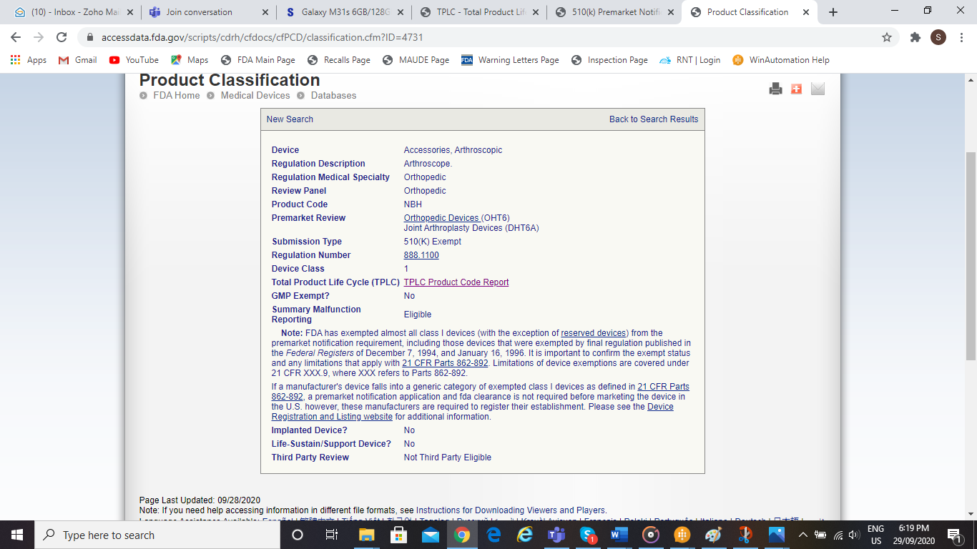

Figure 13: Product Classification Page

### Step # 13: Click on TPLC Product Code Report

**Process**

|  |  |  |  |
| --- | --- | --- | --- |
| Input | Process | Output | Exceptions |
| Click on TPLC Product Code Report | Bot will click on TPLC Product Code Report and capture the top five device problems and MDRs with respective device problem and store it in device table | Figure 14: Top Five Device Problems | NA |

**Output**

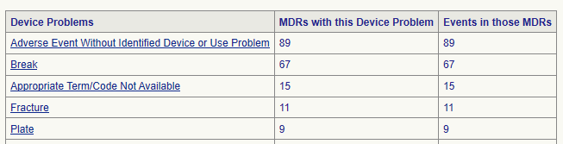

Figure 14: Top Five Device Problems

### Step # 14: Check Premarket Submission link availability.

If Premarket Submission Link is available, then click on it to get to the Classification Product Code.

**Process**

|  |  |  |  |
| --- | --- | --- | --- |
| Input | Process | Output | Exceptions |
| Click on Classification Product Code | Bot will click on Classification Product Code | Figure 15: Product Classification Page | NA |

**Output**

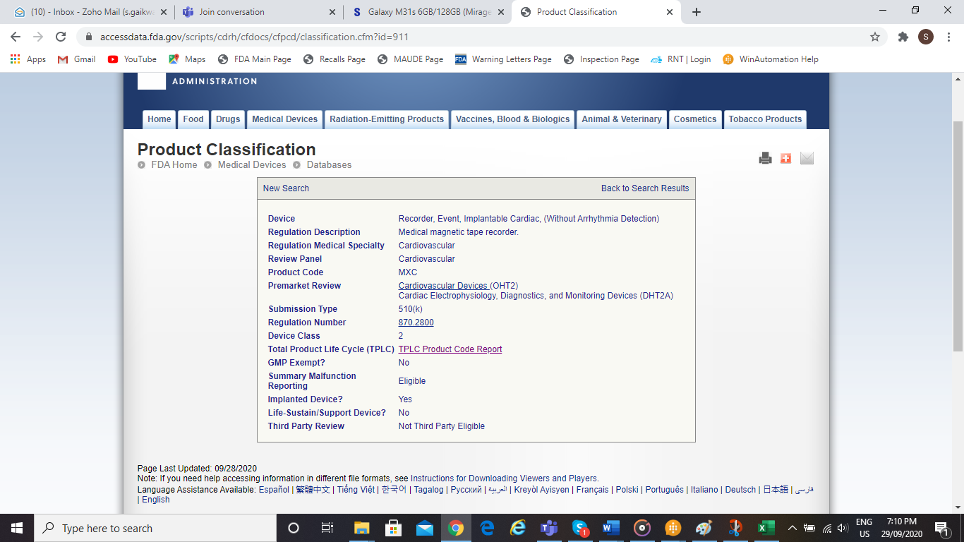

Figure 15: Product Classification Page

### Step # 15: Click on TPLC Product Code Report to capture top five device problems.

**Process**

|  |  |  |  |
| --- | --- | --- | --- |
| Input | Process | Output | Exceptions |
| Click on TPLC Product Code Report | Bot will click on TPLC Product Code Report and capture the top five device problems and MDRs for respective device problem and store it into device table. | Figure 16: Top five device problems | NA |

**Output** 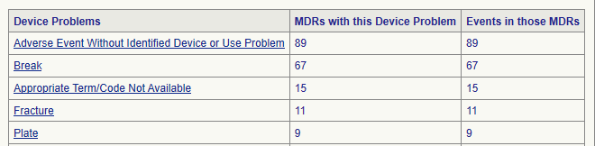

Figure 16: Top five device problems

### Step # 16: Enter the URL to capture 510(k) table

**Process**

|  |  |  |  |
| --- | --- | --- | --- |
| Input | Process | Output | Exceptions |
| URL | Open the URL:  <https://www.accessdata.fda.gov/scripts/cdrh/cfdocs/cfPMN/pmn.cfm> | Figure 17: 510(k) Premarket Notification page | NA |

**Output**

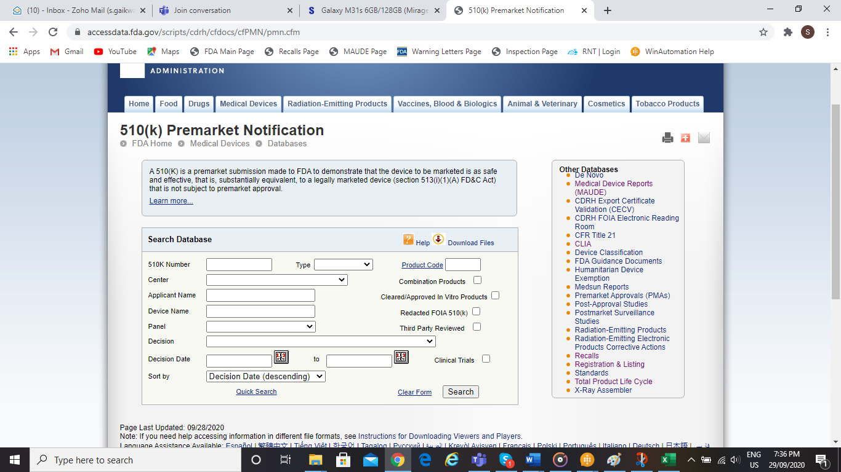

Figure 17: 510(k) Premarket Notification page

### Step # 17: Bot will enter Establishment Name in the “Applicant Name” field.

**Process**

|  |  |  |  |
| --- | --- | --- | --- |
| Input | Process | Output | Exceptions |
| Establishment Name | Bot will enter the Establishment Name into the field “Applicant Name” and will click on Search Button and capture the reflected table and store it into entity summary table. | Figure 18: 510(K) Premarket Notification Table | NA |

**Output**  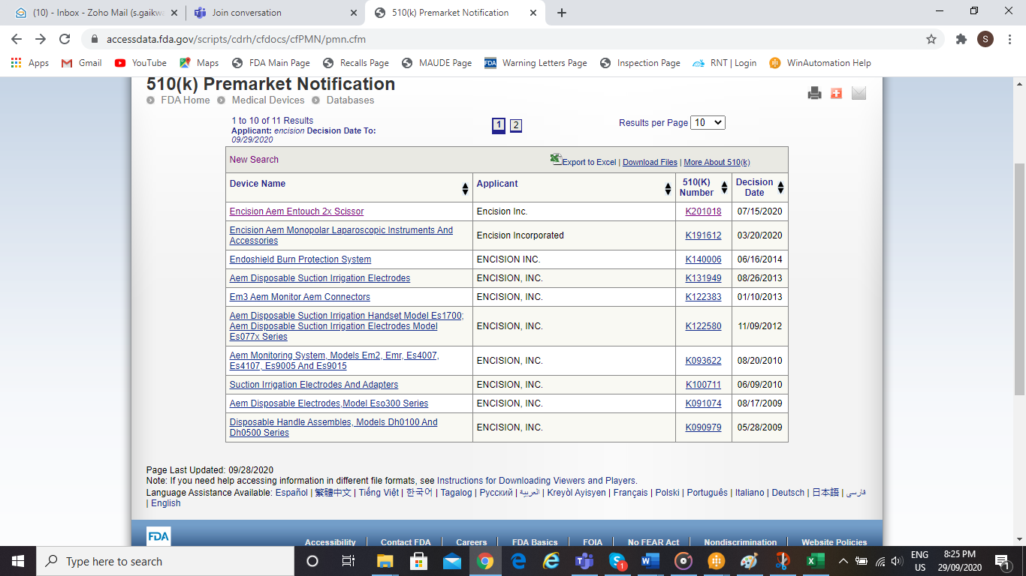

Figure 18: 510(K) Premarket Notification Table

### Step # 18: Enter the URL to capture the Recalls details.

**Process**

|  |  |  |  |
| --- | --- | --- | --- |
| Input | Process | Output | Exceptions |
| URL | Open the URL:  <https://www.accessdata.fda.gov/scripts/cdrh/cfdocs/cfRES/res.cfm> | Figure 19: Medical Device Recalls Page | NA |

**Output**

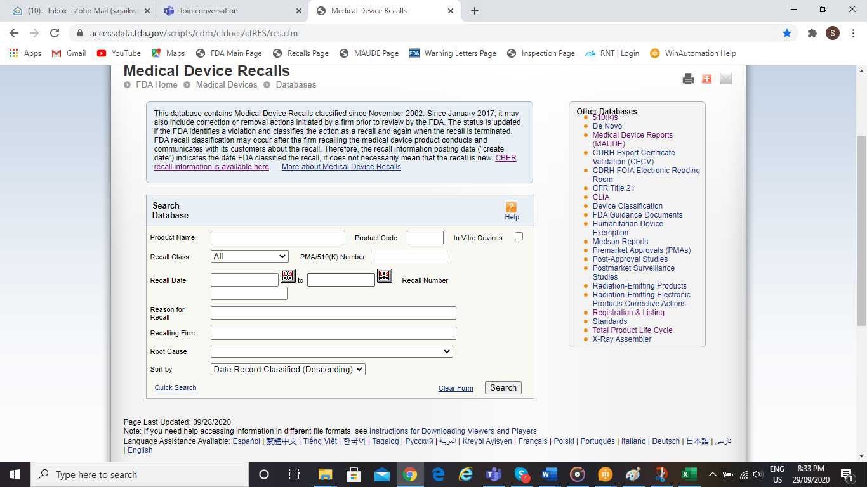

Figure 19: Medical Device Recalls Page

### Step # 19: Bot will Enter Establishment name in the “Recalling Firm” field

**Process**

|  |  |  |  |
| --- | --- | --- | --- |
| Input | Process | Output | Exceptions |
| Establishment Name | Bot will enter the Establishment Name into the field “Recalling Firm” and will click on Search button and capture “Trade Name/Product Description links”, “Trade/Product Description Name”, “Recall Class”, “FDA Posting Date” and populate it into recalls table. | Figure 20: Medical Device Recalls Table | NA |

**Output**

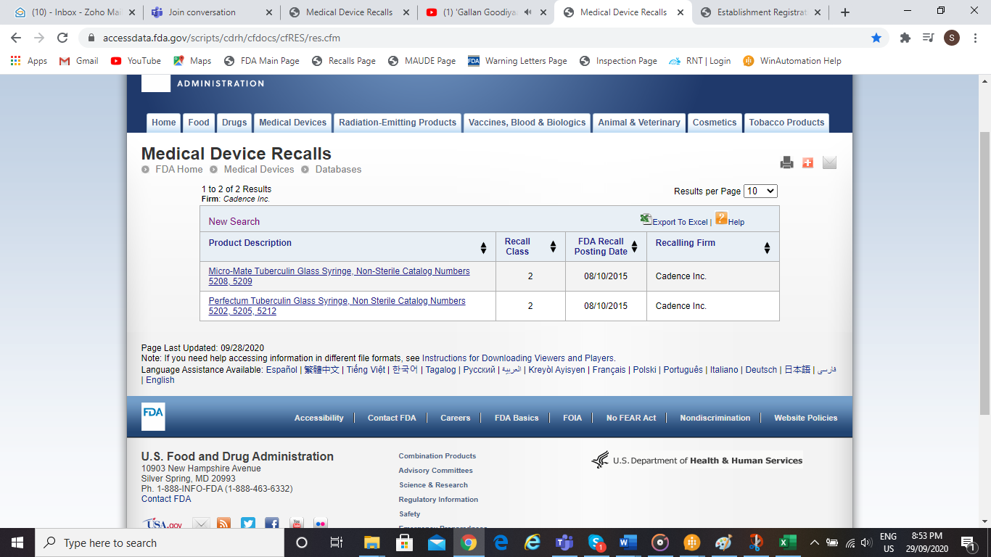

Figure 20: Medical Device Recalls Table

### Step # 20: Click on each link one by one under Product Description

**Process**

|  |  |  |  |
| --- | --- | --- | --- |
| Input | Process | Output | Exceptions |
| Click on each link one by one under Product Description | Bot will click on each link under Product Description and will capture “Recall Status”, ”Manufacturer Reason for Recall ”, “FDA Determined Cause”, “Action”, “Quantity in commerce”, and “Distribution” and store it into recalls table. | Figure 21: Recall Details Page | NA |

**Output**

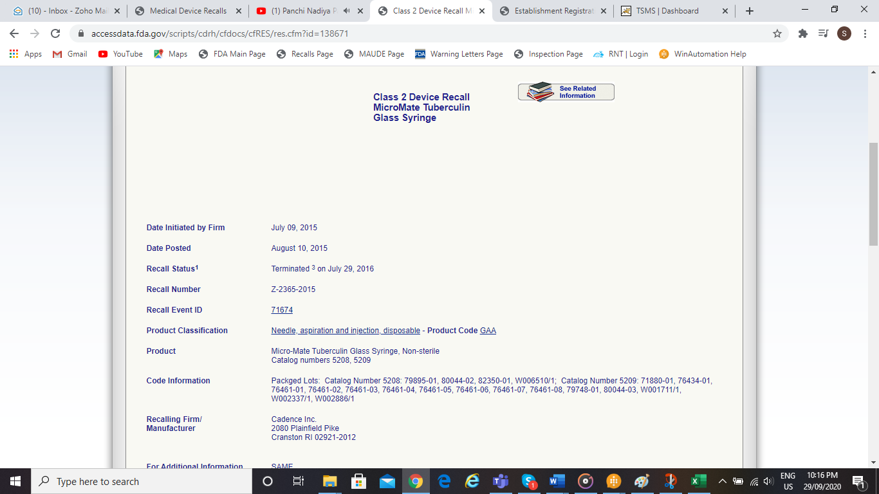

Figure 21: Recall Details Page

### Step # 21: Enter the URL to capture the MAUDE details

**Process**

|  |  |  |  |
| --- | --- | --- | --- |
| Input | Process | Output | Exceptions |
| URL | Open the URL:  [https://www.accessdata.fda.gov/scripts/cdrh/ cfdocs/cfMAUDE/Search.cfm](https://www.accessdata.fda.gov/scripts/cdrh/%20cfdocs/cfMAUDE/Search.cfm) | Figure 22: MAUDE page | NA |

**Output**

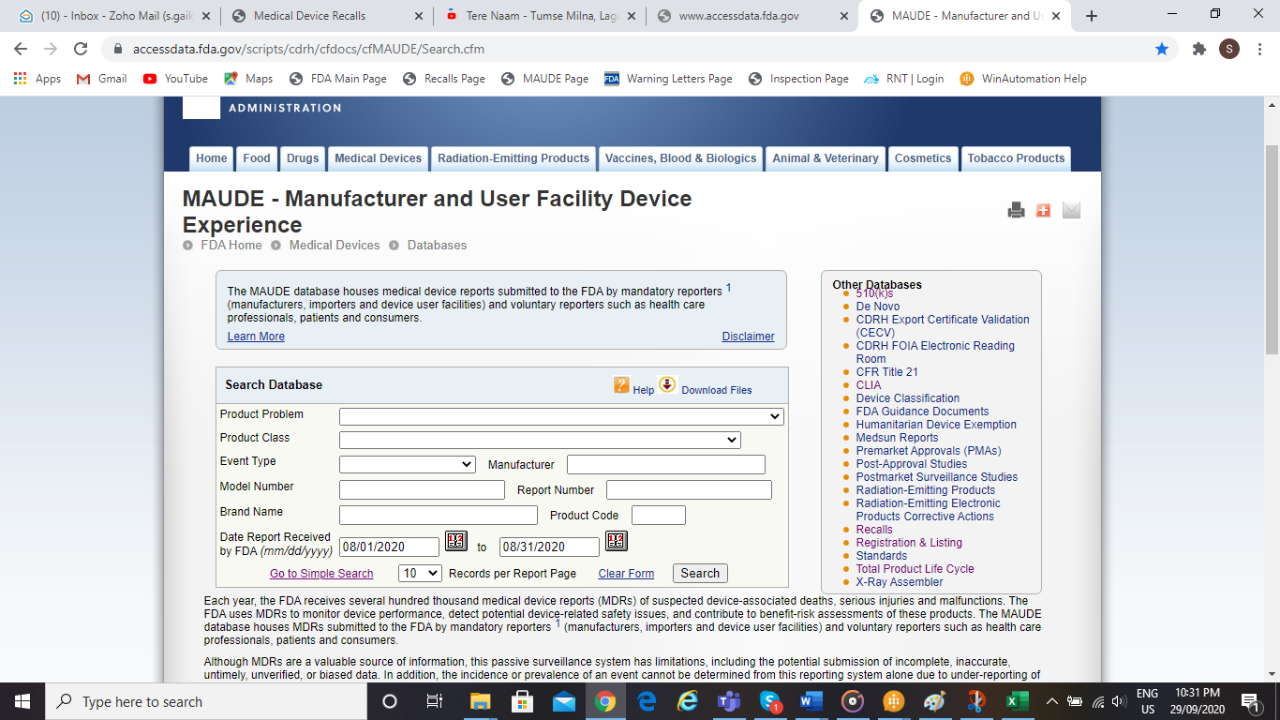

Figure 22: MAUDE page

### Step # 22: Bot will enter Establishment name in the “Manufacturer” field

**Process**

|  |  |  |  |
| --- | --- | --- | --- |
| Input | Process | Output | Exceptions |
| Establishment Name | Bot will enter the establishment name in the Manufacturer field and select the required date range from Date Report Received field and click on search button. | Figure 23: MAUDE Table | NA |

**Output**

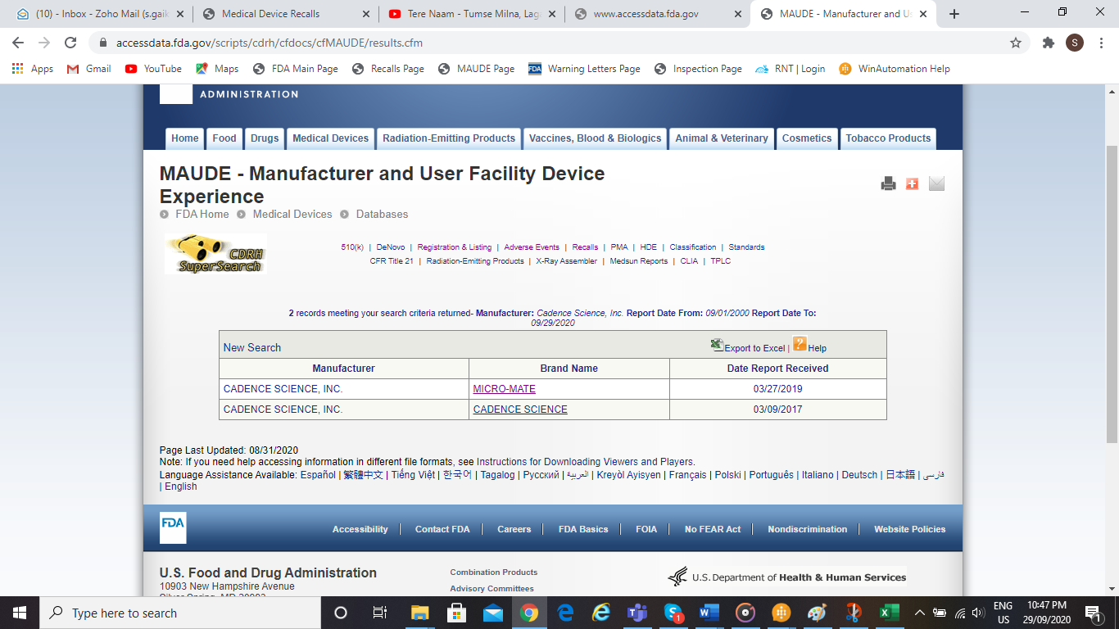

Figure 23: MAUDE Table

### Step # 23: Click on each Brand name

**Process**

|  |  |  |  |
| --- | --- | --- | --- |
| Input | Process | Output | Exceptions |
| Click on each Brand name | Capture “Report Number”, “Event Date”, “Date Received” , “Event Type”, “Report Source”, “Manufacturer-D”, “Manufacturer-G”, “Brand Name”, “Type of Device”, “Manufacturer Review”, “Event text”, “Manufacturer's Narrative”, “Was device available for evaluation?”, “Is this an adverse event report?” and “MAUDE Link” and store it into maude table | Figure 24: Maude Adverse Event Report | NA |

**Output**

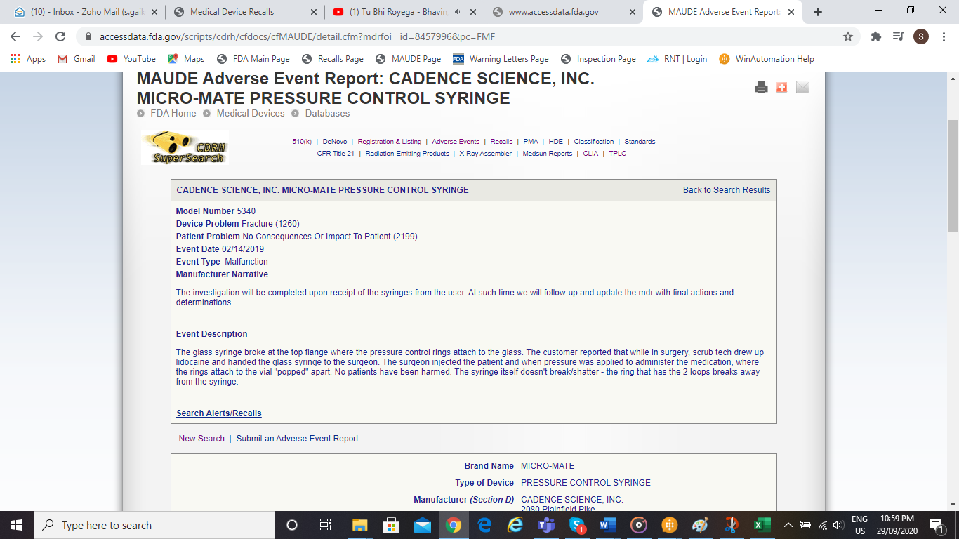

Figure 24: Maude Adverse Event Report

### Step # 24: Enter the URL to capture the Warning Letters details

**Process**

|  |  |  |  |
| --- | --- | --- | --- |
| Input | Process | Output | Exceptions |
| URL | Open the URL:  [https://www.fda.gov/inspections-compliance-enforcement-and-criminal investigations/compliance-actions-and-activities/warning-letters](https://www.fda.gov/inspections-compliance-enforcement-and-criminal%20investigations/compliance-actions-and-activities/warning-letters) | Figure 25: Warning Letter Page | NA |

**Output**

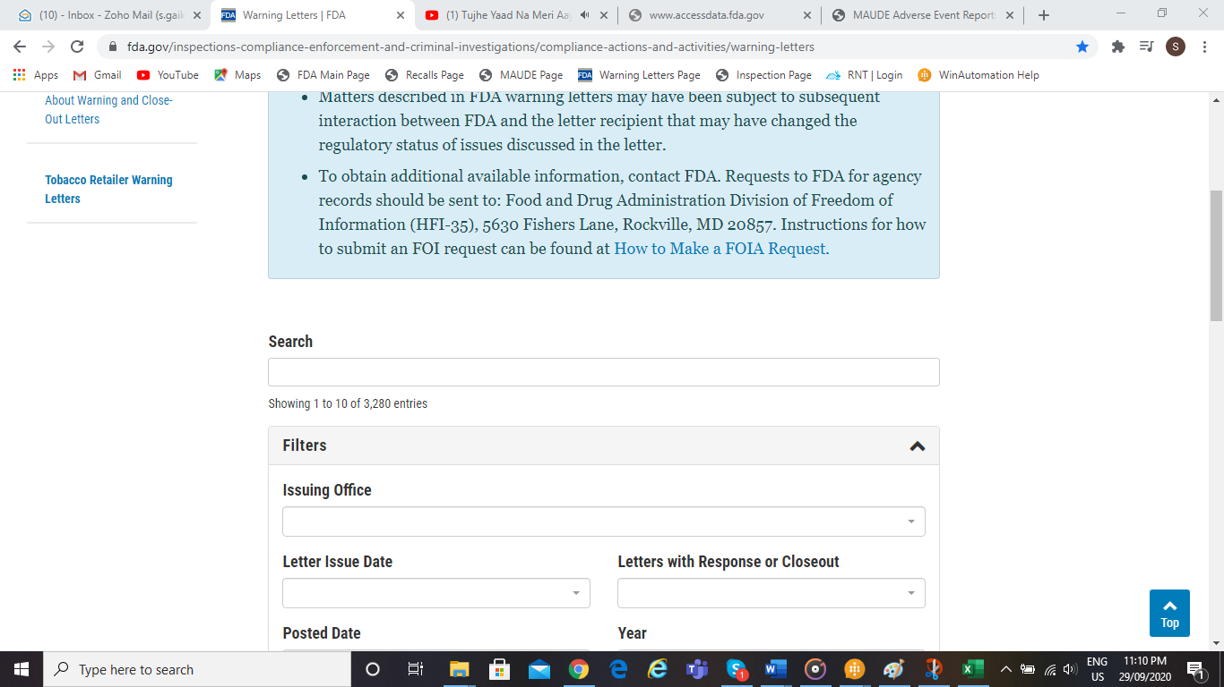

Figure 25: Warning Letter Page

### Step # 25: Enter Establishment name in search field.

**Process**

|  |  |  |  |
| --- | --- | --- | --- |
| Input | Process | Output | Exceptions |
| Establishment Name | Bot will enter the establishment name and will click on Search button and capture “Response Letter” and “Closeout Letter” dates with hyperlink and store it into entity summary table. | Figure 26: Warning Letter Table | NA |

**Output**

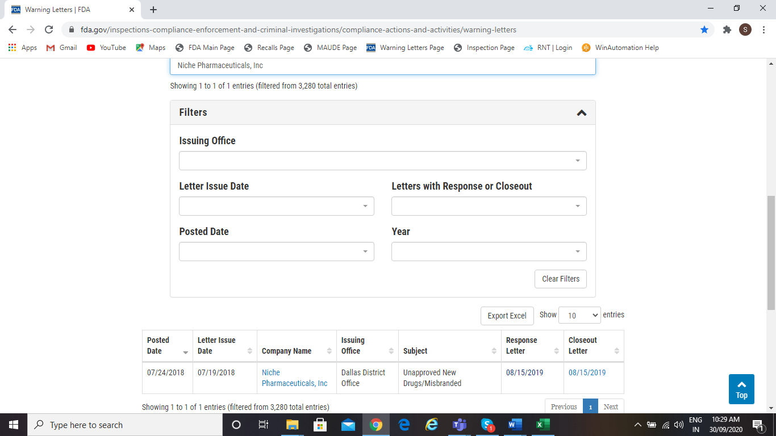

Figure 26: Warning Letter Table

### Step # 26: Bot will enter the URL to capture Inspections details.

**Process**

|  |  |  |  |
| --- | --- | --- | --- |
| Input | Process | Output | Exceptions |
| URL | Open the URL:  <https://www.accessdata.fda.gov/scripts/cdrh/cfdocs/cfRL/rl.cfm> | Figure 27: Inspection Classification Database Search Page | NA |

**Output**

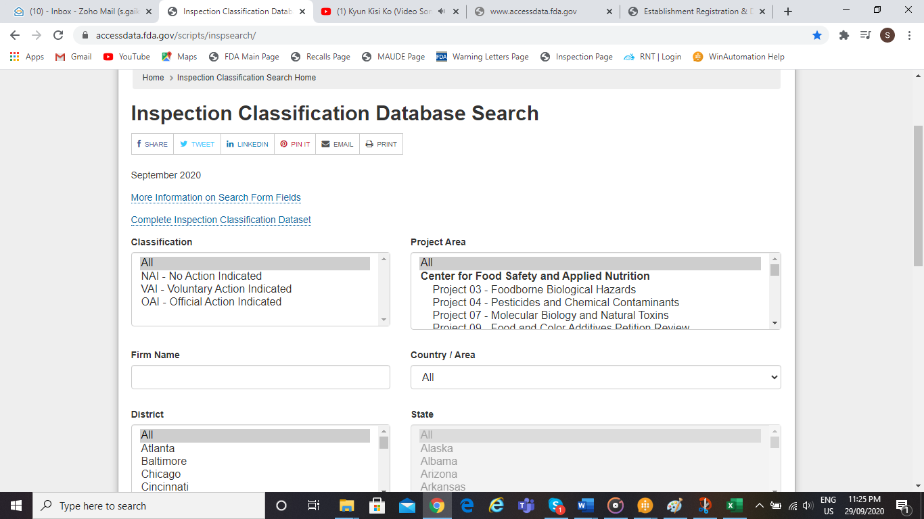

Figure 27: Inspection Classification Database Search Page

### Step # 27: Bot will enter Establishment name in Firm Name field.

**Process**

|  |  |  |  |  |
| --- | --- | --- | --- | --- |
| Input | Process | Output | Exceptions | |
| Establishment Name | Bot will enter the establishment name in the Firm Name field and search. Bot will capture “City”, “State”, “Zip Code”, “Inspection End Date”, “Project Area”, and “Classification Name” and store it into inspections table. | Figure 28: Inspection Classification Database Search Table | | NA |

**Output**

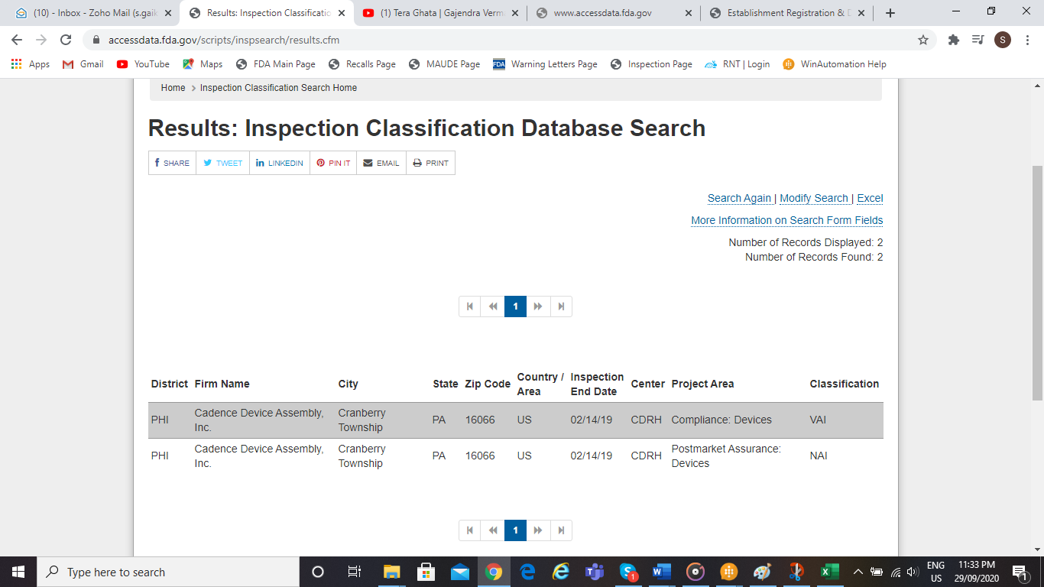

Figure 28: Inspection Classification Database Search Table

### Step # 28: Retrieving details from database

**Process**

|  |  |  |  |  |
| --- | --- | --- | --- | --- |
| Input | Process | Output | Exceptions | |
| Establishment name | UW will enter the establishment name in the Search field. And can download / view the details of provided establishment name | Figure 29: Output screen | | NA |

**Output**



Figure 29: Output screen

## Business Exceptions Handling

The Business Process Owner and Business Analysts are expected to document below all the business exceptions identified in the automation process. These can be classified as:

* Known: Previously encountered. A scenario is defined with clear actions and workarounds for each case.
* Unknown: The new situation was never encountered earlier. It can be caused by external factors. It cannot be predicted with precision. However, if it occurs, it must be communicated to an authorized person for evaluation

### Known Exceptions

The table below reflects all the business process exceptions captured during the process evaluation and documentation. These are known exceptions, met in practice before. For each of these exceptions, define a corresponding expected action that the automation solution should complete if it encounters the exception.

| **#** | **Exception name** | **Step** | **Parameters** | **Action to be taken** |
| --- | --- | --- | --- | --- |
| 1 | If the Establishment name does not already exist in the database | Step # 1: Enter “Establishment Name” in the Search box. | If no records are found | If no records are found the bot will be triggered to extract details for provided establishment name. |
| 1 | If Establishment name does not exist on FDA weblink | Step # 6: Bot will enter “Establishment or Trade Name” in the respective field. | If no records are found | **PowerApps**- An error message box will be displayed with the message “<provided establishment name> does not exists. Please provide correct / another establishment name.” |
| 2 | If Summary link is not found | Step # 11: Click on Premarket Submission Number | If no link is found | **PowerApps**- Device name will not be hyperlinked in Device tab. |
| 3 | If CDRH link is not found | Step # 11: Click on Premarket Submission Number | If no link is found | **PowerApps**- Message will be logged as “No recalls found” in Entity Summary tab. |
| **PowerApps**- Recalls label will not be hyperlinked in Device tab. |
| 4 | If Premarket Submission Number is not available | Step # 12: If Premarket Submission Number Is not available, click on Product Code | If premarket submission number is not found | **PowerApps**- Recalls label will not be hyperlinked in Device tab. |
| 5 | If 510(k) records are not available. | Step # 16: Enter the URL to capture the 510(k) table | If no records are found | **Database**- In error table log a message 510(k) table not found. |
| **PowerApps**- In Entity Summary tab log message “Result Not Found”. |
| 6 | If no records are found for Recalls. | Step # 18: Enter the URL to capture the Recalls details. | If no records are found. | **Bot-** Navigate the Bot to MAUDE search page. |
| **PowerApps**- In recalls tab log message “Result Not Found”. |
| 7 | If no records are found for MAUDE. | Step # 21: Enter the URL to capture the MAUDE details | If no records are found. | **Bot-** Navigate to Inspections search page. |
| **PowerApps**- In MAUDE table log message “Result Not Found”. |
| 8 | If no records are found for Warning Letters. | Step # 24: Enter the URL to capture the Warning Letters details | If no records are found | **PowerApps**- “NA” in Entity Summary tab. |
| 9 | If no records are found for Inspections. | Step # 26: Bot will enter the URL to capture Inspections details. | If no records are found | **Bot-** Navigate to Warning Letters page |
| **PowerApps**- In inspections tab log message as “No Results Found” |
| 10 | FDA Access Data Error | For all steps | FDA Access Data Error | **Bot-** Stop process for existing establishment name.  and |
| **Database- E**nter error message in log file table. |
| **PowerApps-** An error message box will be displayed with the message “FDA Access Data Error occurred. Please provide another establishment name.” |
| 11 | If no records are found. | For all steps | - | **Database-** Enter establishment name, error message & time stamp in error file table. |

Table 4: Known Business Exceptions for Bot

### Unknown Exceptions

For all the other unanticipated or unknown business (process) exceptions, the automation solution should:

Example:

Send an email notification at XYZ@domain.com [insert full name, function, and email address] with the original email and error message screenshot attached.

## Application Error and Exceptions Handling

A comprehensive list of all errors, warnings, or notifications should be consolidated here with the description and action to be taken by the automation solution.

Errors identified in the automation process can be classified as:

* Known: Experienced previously, action plan or workaround available for it.
* Unknown: The new situation was never encountered before or may happen independent of the applications used in the process.

### Known errors or Exceptions

The table below reflects all the errors identifiable in the process evaluation and documentation.

For each of these errors or exceptions, define a corresponding expected action that the automation solution should complete if it is encountered.

| **#** | **Error name** | **Step** | **Parameters** | **Action to be taken** |
| --- | --- | --- | --- | --- |
| 1 | FDA Access Error | - | Error Message | Close the application and rerun the sequence. |
| 2 | WinAutomation credentials not working | - | Account deactivated | Send an email with a screenshot to a supervisor. |

Table 5: Known Application Exceptions for Bot

### Unknown Errors and Exceptions

For all the other unanticipated or unknown application exceptions/errors, the automation solution should:

{Define a corresponding expected action that the automation solution should complete if it encounters an error or unknown exception.}

Example:

Send an email notification at XYZ@domain.com [insert full name, function, and email address] with the original email and error message screenshot attached.

## Assumptions

| **A - #** | **Assumption** | **Impacted Business Req #** |
| --- | --- | --- |
| A 1.0 | FDA database will not go down during bot’s run-time | ALL |

Table 6: Assumptions for the Bot

## Dependencies

*The table below provides the list of identified dependencies:*

| **D - #** | **Dependency** | **Impacted Business Req. #** |
| --- | --- | --- |
| D 1.0 | Underwriter inputs/provides correct establishment name. | ALL |

Table 7: Dependencies for the Bot

## Constraints

*The table below provides a list of identified constraints:*

| **#** | **Constraints** | **Impacted Business Req. #** |
| --- | --- | --- |
| C 1.0 | The required data fields and format in final output report have to be captured in the business requirements sessions. | ALL |

Table 8: Constraints for the Bot

## Risks

*The table below provides a list of potential risks that are identified:*

| **R - #** | **Risk** | **Impacted Business Req. #** | **Probability** | **Risk Treatment/**  **Response** |
| --- | --- | --- | --- | --- |
| R 1.0 | Incomplete data capture/errors happen if FDA database go down during run-time |  |  | Send an email with a screenshot to Underwriter. |

Table 9: Risks for the Bot

# Acronyms and Glossary

|  |  |
| --- | --- |
| **Acronym / Term** | **Expansion / Definition** |
| PDD | Process Design Document |
| FDA | (U.S) Food and Drug Administration |
| UW | Underwriter |

Table 10: Acronyms and Glossary

# Change History

|  |  |  |  |  |
| --- | --- | --- | --- | --- |
| **Version #** | **Overview of Changes** | **Sections Changed** | **Changed By** | **Date** |
| 0.1 | Initial draft created | All | Pallavi Thakare | 24-Sep-2020 |
| 1.0 | Review comments incorporated | All | Pallavi Thakare | 06-Oct-2020 |
| 1.1 | Input to the Bot and Cross-references incorporated | Section 3, 3.2.1, 3.2.10, 3.3.1 | Pallavi Thakare | 12-Oct-2020 |
| 1.2 | Review comments incorporated | Process Overview, Dependencies and Constraints. | Pallavi Thakare | 15-Oct-2020 |
| 1.3 | Changed approach comments incorporated | Section 3, 3.1, 3.2, 3.3.1,5 | Pallavi Thakare | 10-Nov-2020 |

Table 11: Change History